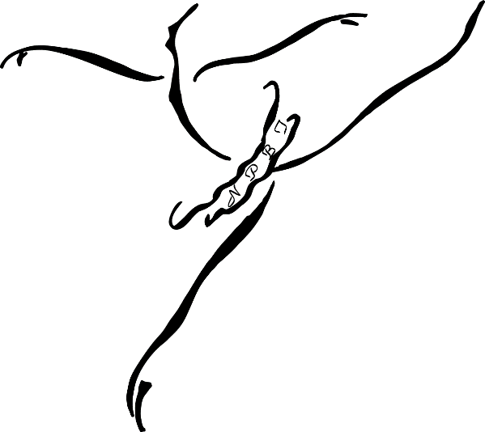
Ray Delle Robbins Sponsorship Application 2021-2022
New Paltz Ballet Theatre, Inc.

“It is the intent of the New Paltz Ballet Theatre, Inc. to recognize the contribution of artistic talent and love given to our productions by the incredibly gifted Ray Delle Robbins. Her vision from paper sketches to fabric to costume construction will continue to amaze our audiences for years to come. Ray Delle’s devotion to her art and her expertise in her craft are an inspiration to us all.”

This application must be completed in its entirety with attachments as required in order to be considered for this financial sponsorship.

Today’s Date_______________________________ Date of Birth__________________________

Name______________________________________ Email Address_________________________

Address_____________________________________________________________________________________

Home Phone_________________________________ Cell Phone____________________________

School Grade Level ________ School Attending______________________________________

Parent/Guardian’s Name___________________________ Occupation___________________________

Gross Household income____________________ # of family members residing in primary residence ________

Year started at New Paltz School of Ballet_____________

Current NPSB level_______________________ How many classes per week_______________________

Please list any additional support you have provided to NPBT & NPSB: (example: class helper, class teacher, Nutcracker helper-Angel helper, Party Scene helper): ________________________________________________________________

____________________________________________________________________________________________

Please list previous Ballet Schools and years attended:

__________________________________________ _______________________________________

Are you enrolled at another dance studio? Yes No If yes, please let us know where and how many classes per week you are taking: _________________________________________________________________________

Have you been awarded a dance scholarship in the past? Yes No

If yes, from who/where _________________________________________________________________________

Any additional things you would like us to take into consideration. Please write your thoughts here:
(this is not required)

Required attachment(s) for all applicants:

Short Essay: a typed single page on “Why ballet is important to you”.
DO NOT put your name on it, and include with your application.

Financial: provide one of the following:
Proof of free/reduced lunch -or-
Most recent completed tax return -or-
Proof of financial aid you receive in order to attend any Private or Parochial school

Your financial information it will be reviewed solely by the Artistic Directors and returned to you immediately following its review.

APPLICATION DUE DATE: Monday, November 8, 2021 – 7:00 pm

********************************************************************************************************************************
Please paperclip the Essay to your completed application. Put into a sealed envelope with RDR Application on the front of the envelope and place in the New Paltz Ballet Theatre mailbox at the studio.

Please provide a separate form with the essay as required for each child applying.

Completed applications become the property of the New Paltz Ballet Theatre, Inc. with the exception of the applicants’ financial information which is returned.

All information is required to be completed. Incomplete applications will not be considered, and returned.

**** IMPORTANT ****
Please let Miss Lisa know, in writing, that you are applying for the RDR Sponsorship Thank you.

